

FURTHER MATHS
TRIAL EXAM 1
SOLUTIONS
2004

_____________________________________________________________________

Section A Section B – answers
answers

Core Module 1 Module 2 Module 3 Module 4 Module 5

1. D Arithmetic Geometry Graphs Business Networks
2. B and and and related and
3. B applications trigonometry relations mathematics decision
4. A maths
5. C 1. B 1. E 1. A 1. E 1. D
6. C 2. B 2. D 2. C 2. A 2. B
7. E 3. E 3. B 3. D 3. D 3. E
8. C 4. E 4. E 4. D 4. B 4. C
9. E 5. B 5. C 5. E 5. D 5. D
10. C 6. C 6. D 6. B 6. B 6. A
11. A 7. D 7. D 7. B 7. C 7. B
12. D 8. C 8. A 8. D 8. E 8. E
13. A 9. D 9. B 9. C 9. C 9. C
___________________________________________________________________________

Section A: Core - solutions

Question 1

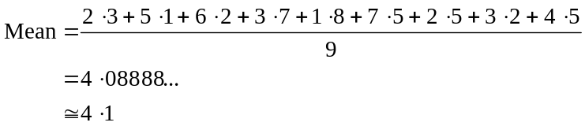
The answer is D.

Question 2

A boxplot, a scatterplot, a barchart and a histogram are all used to display univariate data like the data we have.
A scatterplot is used to display the association between two numerical variables.
Therefore the scatterplot is not appropriate to use in this situation.
The answer is B.

Question 3

There are 21 entries on the stem plot for May. Hence the car dealer traded for 21 days.
The answer is B.

Question 4

The centre of the distribution of the number of cars sold on each trading day during September is higher than that during May and hence the number of cars sold in September is on average greater.
The distribution of the number of cars sold during a trading day in May is symmetrical and has a larger range whereas the distribution of the number of cars sold during a trading day in September is positively skewed and has a smaller range. Hence the September distribution is less variable than the May distribution
The answer is A.

Question 5

The mass is bell-shaped with a mean of 2 500g and a standard deviation of 50g. Now 2550 is 1 standard deviation above the mean. We know that for bell-shaped distributions 68% of data lies between 1 standard deviation either side of the mean.
So 32% of data lies below 1 standard deviation below the mean or above 1 standard deviation above the mean.
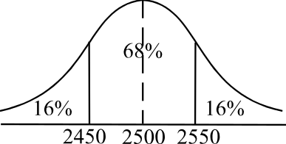
Because of the symmetry of the bell-shaped curve,
this means that 16% of data lies above 1 standard
deviation above the mean.
Now 16% of 10 000 = 1 600.
So 1 600 packets have a mass greater than 2 550g.
The answer is C.

Question 6

We need to look at the 30-45 age group which is the middle column and we need to look at the top block of the column that represents regular attendance.
The percentage of regular attendees aged between 30-45 is 35%.
The answer is C.

Question 7

The first four statements are all true.
For A., 28 pieces of data give us fourteen pairs of points on the scatterplot. The residual value (when the regression line is fitted) for each of these 14 pairs is shows on the residual plot.
For B., there is no pattern in the residual plot and hence the two variables are probably linear.
For C., there is no residual value greater than 3.
For D., because of the same reason as B., the quality of fit of the regression line is good.
For E., it is not the size of the residuals but rather the random pattern created by the residuals that tells us whether the relationship is linear.
The answer is E.

Question 8

Both the variables are numerical and hence not categorical.
Both the variables are continuous and hence not discrete.
The variable age, is independent and the variable height, is dependent. Only option C reflects all this.
The answer is C.
Question 9

From the scatterplot, there is a moderately strong, positive relationship between age and height. Hence the correlation coefficient would be closest to 0.7.
The answer is E.

Question 10

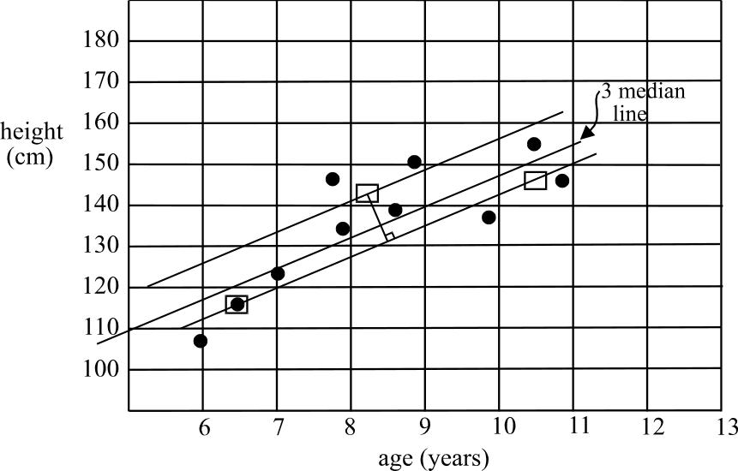

The intercept on the vertical axis is closest to 110.
The answer is C.

Question 11
For the data shown on this scatterplot, you could use a 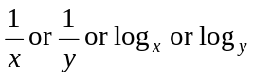 transformation.
The only alternative that offers a correct answer is option A.
The answer is A.

Question 12

Year | Sales ($1000’s)
 |  | Two term average
3 | 57 |  | Two term average with centring
 |  | 54
4 | 51 |  | 55
 |  | 56
5 | 61

The answer is D.

Question 13

The point in question is in the middle group of data. Changing it does not change the median of the middle group. Since the medians of the two "outside" groups of data are unchanged, the three median line is unchanged and hence the slope is the same.

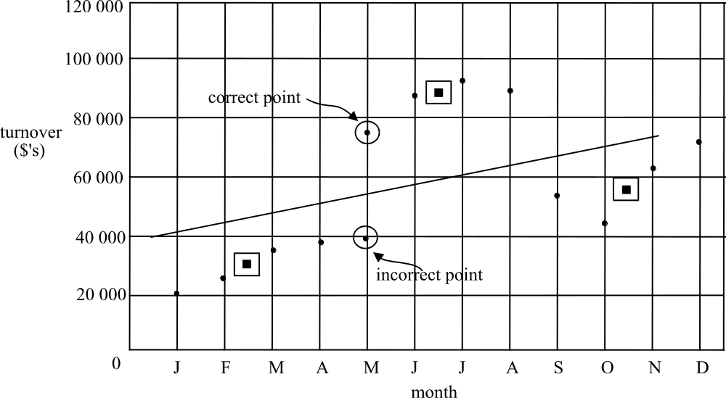

The answer is A.
Module 1: Number Patterns and Applications

Question 1

Method 1
Use your calculator to generate the sequence. The twentieth term is 141.

Method 2
The sequence is arithmetic with 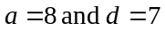.
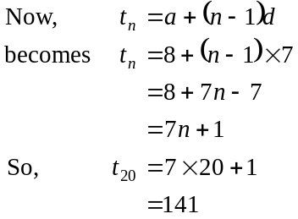
The answer is B.

Question 2

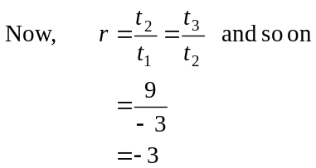
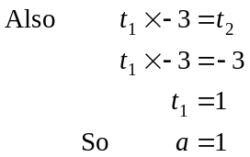
So 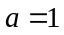 and 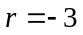
The answer is B.

Question 3

For the ratio 8:5, the five parts represents domestic animals and the vets see 120 in a week. So one part of the ratio is equal to 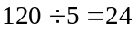. There are a total of 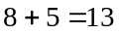 parts. So the total number of animals seen in a week is 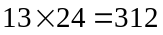.
The answer is E.

Question 4

The number of porcelain dolls Muriel has after the n^{th} year of collecting them is an arithmetic sequence with an unknown value of a and 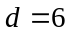.

Method 1
After her 4th year of collecting them she has 25.
So, after the 3rd year she would have had 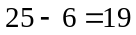.
After the 2nd year, she would have had 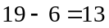.
After the 1st year, she would have had 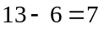.
So 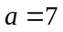, that is, she inherited 7 dolls.
Using a calculator to generate the sequence we see that she would have 79 porcelain dolls in her collection after thirteen years.

Method 2
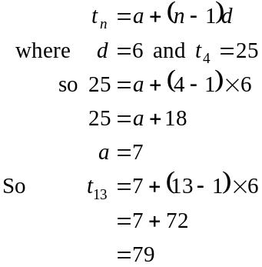

Method 3
Muriel has 25 porcelain dolls in her collection after 4 years. Nine years later she will have another 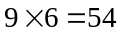 to add to her collection which will give, after 13 years, a total of 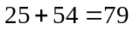 dolls.

The answer is E.

Question 5

After the first year of the policy being implemented, there were
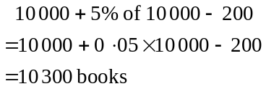
After the second year of the policy being implemented, there were
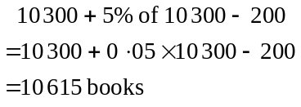
Note – the number of books in the library should be increasing. If your calculations don’t show this then check your working.

The answer is B.

Question 6

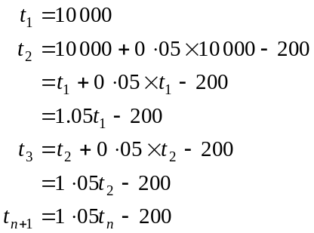
The answer is C.

Question 7

The sequence defined by the difference equation is an arithmetic sequence since each term has 6 added to it to obtain the subsequent term.
For an arithmetic sequence,
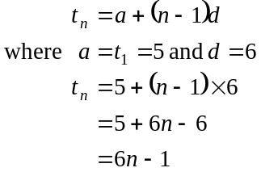
The answer is D.

Question 8

The number of the top of the range hoses produced by the manufacturer decreases by 15% each year so options D and E cannot be correct. A decrease of 15% each year means that the greatest decrease will be in the first year, the second greatest decrease will be in the second year and so on. Only option C shows this.
The answer is C.

Question 9

Let 2001 be Year 1. We have a geometric sequence with 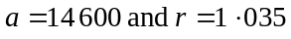. We wish to find the sum of the first six terms of this sequence.
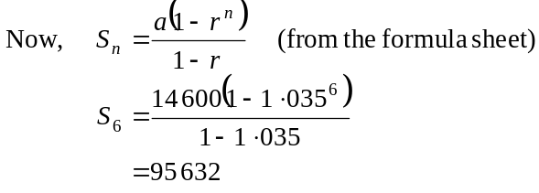
The answer is D.

Module 2: Geometry and Trigonometry

Question 1

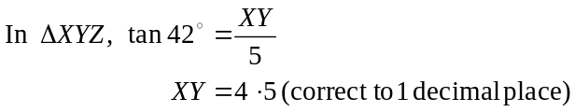
The answer is E.

Question 2

ΔMNP is an isosceles triangle
So 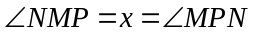
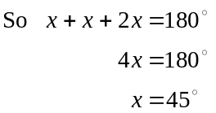
The answer is D.

Question 3

Since ABCDE is a regular pentagon, the size of each of the interior angles is given by 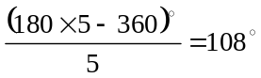.
Hence 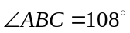
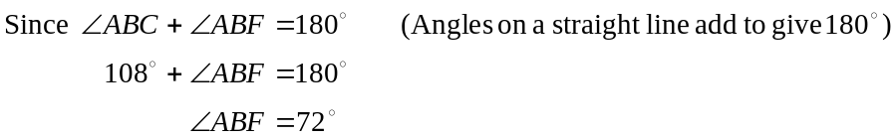
The answer is B.

Question 4

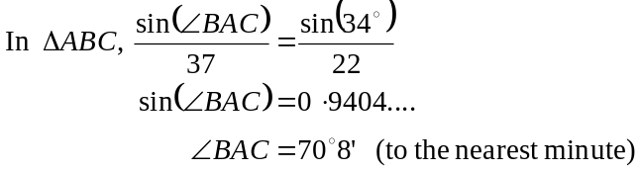
The answer is E.
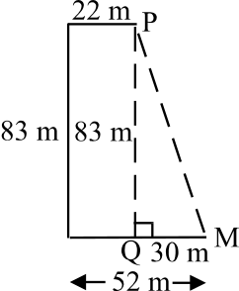

Question 5

In the diagram at right, in ΔPMQ,
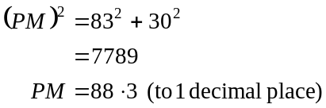
The answer is C.

Question 6

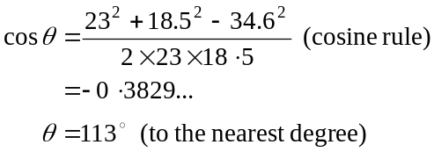
The answer is D.

Question 7
To express the distance on the map to the actual distance as a ratio, the quantities must be in the same unit.
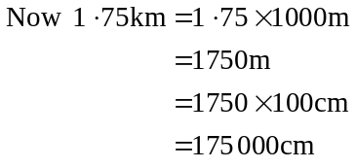
So the scale on the map is
7:175 000
1:25 000
The answer is D.

Question 8

The area of the larger triangle is 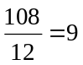 times the area of the smaller triangle.
Therefore the side lengths of the larger triangle are 3 times the length of the side lengths of the smaller triangle. So the required ratio is 1:3.
The answer is A.

Question 9
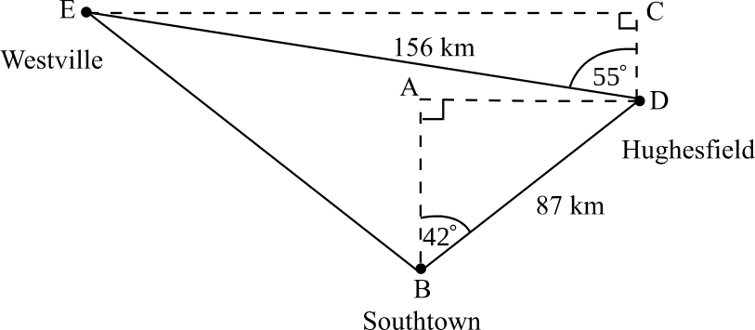

Introduce two right-angled triangles.
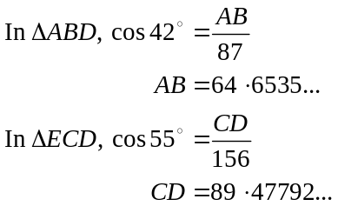
So Westville is 154 (to the nearest km) north of Southtown.
The answer is B.

Module 3: Graphs and relations

Question 1

Every point on the vertical line shown has an x-coordinate of 3. The equation of the line is simply 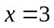.
The answer is A.

Question 2

The horizontal line through 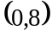 has equation 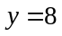, hence the region below that line will be described by the inequality 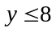.
The region to the left of the line 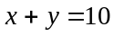 is described by the inequation 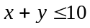. To check this, pick a point, say 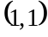. Now 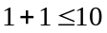, so the point lies in the region described by .
The answer is C.

Question 3

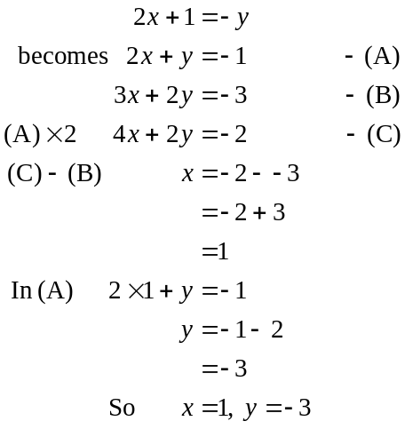
The answer is D.

Question 4

The maximum value will occur at one of the corner points of the feasible region.
Reading from the graph, the corner points are 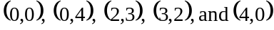.
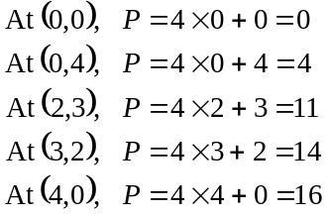
The answer is D.

Question 5

The graphs given are the graphs of y against .
Now 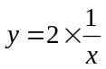 so only the point 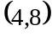 satisfies this, that is, 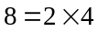.
The answer is E.

Question 6

The weight constraint is
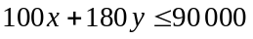
Also, 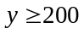 as stated in Paul’s contract and 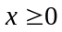.
The answer is B.

Question 7

The cheapest way of
- buying up to 5 iced doughnuts would be to buy the 5 pack which would cost $1.00.
- buying 6 to 10 iced doughnuts would be to buy the 10 pack which would cost $1.50.
- buying 11 to 15 iced doughnuts would be to buy a 5 pack and a 10 pack which would cost 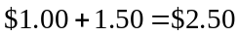.
- buying 16 to 20 iced doughnuts would be to buy two 10 packs which would cost 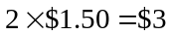.
Only graph B shows this.
The answer is B.

Question 8

The call-out fee is the intercept on the vertical axis of the graph, that is, it is the fee paid when zero hours of repair have been performed. For Sudsy and Co., the call-out fee is therefore $70. The hourly fee is given by the gradient of the graph. Choose any segment of the Sudsy and Co., straight line, say between 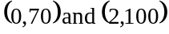.
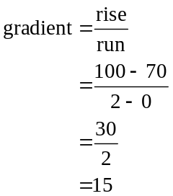
The hourly rate for Sudsy and Co. is $15.
The answer is D.

Question 9

If the repairs take between 2 to 3 hours then Sudsy and Co. is cheaper. (Note that before 2 hours, ABC repairs is cheaper).
At 2 hours the cost is $100.
At 3 hours, the cost is $115 with Sudsy and Co.
The answer is C.
Module 4: Business-related mathematics

Question 1
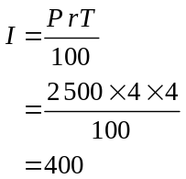
The investment after 4 years was worth 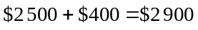.
The answer is E.

Question 2

The machinery depreciates in total by 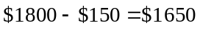.
Since it depreciates at $275 per year, 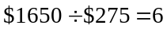.
So Bob will need to replace it in 6 years.
The answer is A.

Question 3

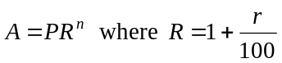
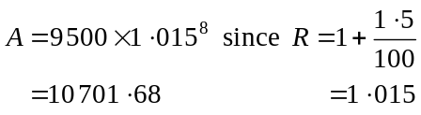
The answer is D

Question 4

At the end of the eighth quarter of the investment, (i.e. at the end of 2 years) the amount in the account was $10 701.68 from Question 3.
The amount in the account at the end of the ninth quarter was given by
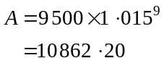
The amount of interest earned in the fifth quarter is .
The answer is B.

Question 5

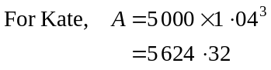
Kate receives 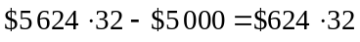 in interest.
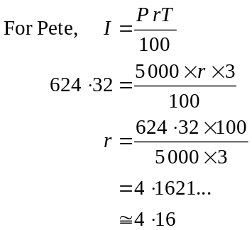
The answer is D.

Question 6

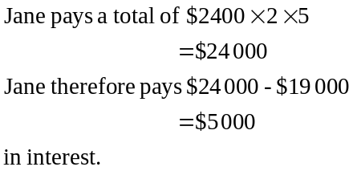
So the flat rate of interest per annum is
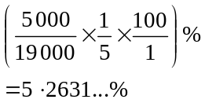
Now effective rate of interest is given by
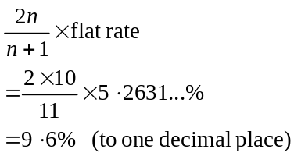
The answer is B.

Question 7

George invested $15 000 initially so options B and E are incorrect.
The amount in George’s account increases by an increasing amount each year. This is because the interest is compounding; that is, George earns interest on the interest he has already earned.
Option A shows an increase in the amount of the investment over the years but the increases are becoming less each year.
Option D shows an increase in the amount of the investment by the same amount each year.
Option C is the correct option.
The answer is C.

Question 8

The first interest charged is $230.
Let x = the quarterly interest rate.
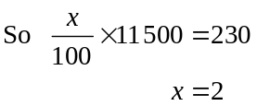
So the annual interest rate charged is 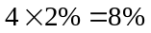.
Check your answer (if you have time) with the interest charged on 31 March 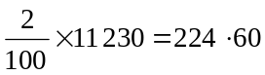 as given.
The answer is E.

Question 9

The left hand side of the equation is zero – so for the calculation the amount left owing is nothing.
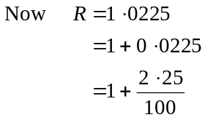
So r, the interest rate per period is 2.25%. Since the annual interest rate is 9%, the period must be quarterly. There are 24 periods for the life of the loan, so after 24 quarters or 6 years the loan will be paid off.
The answer is C.

Module 5: Network and decision mathematics

Question 1

A Hamiltonian path passes through each vertex exactly once and doesn’t finish on the vertex it started on.
The answer is D.

Question 2

Mr Banks can do, security or music or parental supervision. So all options are fine for this.
Miss Curtis can do catering or ticketing so all options are fine for this.
Mr Raskuti can do security or parental supervision.
Option B has him doing ticketing. Hence option B is not acceptable.
The answer is B.

Question 3

To have an Euler circuit, all the vertices of the graph must have an even degree. Vertices A, B, E and F have an even degree.
Vertices C and D have an odd degree, hence an arc along CD will solve the problem.
The answer is E.

Question 4
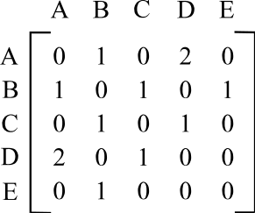

From the matrix,
A and B are connected by 1 arc.
This rules out option D.
A and D are connected by 2 arcs.
This rules out option A.
B and C are connected by 1 arc.
This rules out option B.
B and E are connected by 1 arc.
This rules out option E.
C and D are connected by 1 arc.
Only option C reflects all the correct arcs.
The answer is C.

Question 5

Euler’s formula applies to connected, planar graphs.
The answer is D.

Question 6

A cut has to “cross” a network. To test whether a network has been crossed, see whether taking away the arcs crossed by the cut still allows flow from A to Z. If it does, then we do not have a proper cut and hence the flow through the network cannot be properly measured.
By looking at the graph we see that cut A does not “cross” the network. If we took away the arcs it cuts, things could still flow from A to Z (along some of the lower arcs).
The answer is A.

Question 7

Option B is the correct option.
Option A’s first incorrect entry is for Task C. Option C’s first incorrect entry is for Task E. Option D’s first incorrect entry is for Task A. Option E’s first incorrect entry is for Task G.
The answer is B.

Question 8
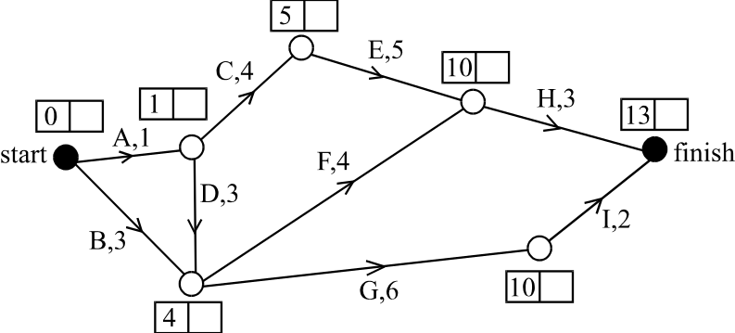

The first number in the box near each node gives the earliest start time. The minimum time for the project to be completed is 13 days.
The answer is E.

Question 9

To reduce the overall project by one day, one of the tasks on the critical path would have to be reduced in time.
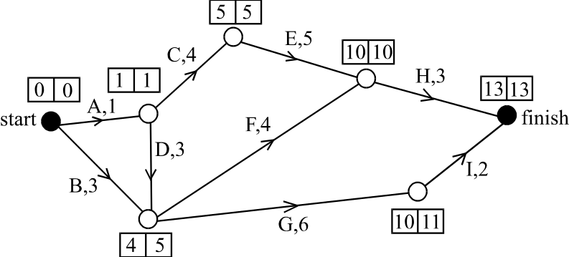

The second number in the box near each node gives the latest start time.
From this, we see that the critical path is A, C, E, H.
So, reducing any of these tasks will reduce the time taken for the project.
The answer is C.

